**Serenity and Cucumber Framework**

Maven is the recommended build tool for Serenity BDD.

You can add Serenity BDD to an existing Maven project by adding the corresponding dependencies to your **POM.XML** file. All Serenity BDD projects need the following core dependency:

Note: Main dependency

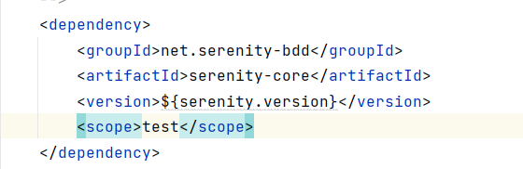

For Cucumber you will need the following dependency:

Note: Cucumber version might change

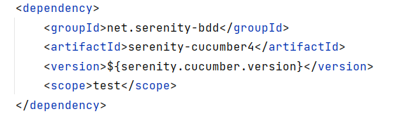

**Serenity Maven Plugin**

If you want to generate the Serenity reports whenever you run **mvn clean verify**, you can use the **serenity-maven-plugin** to do that:

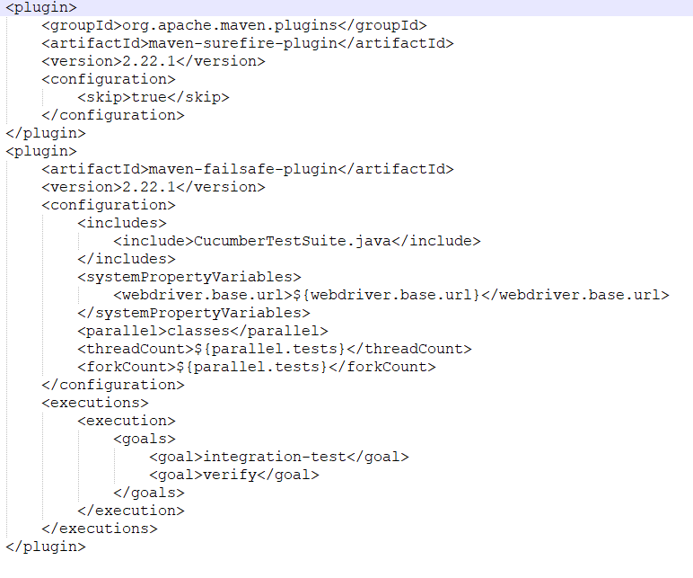

**Creating a New Project Serenity + Cucumber for OrangeHRM site**

## Main files in Serenity Framework

## serenity.properties

## serenity.conf

1. CucumberTestSuite Java file
2. Stepdefinitions Java file

## 

**serenity.conf**

## The simplest way to configure the driver you want to use is in your project's serenity.conf file (which you will find in src/test/resources folder).

## Configuring the base URL for different environments

**serenity.properties**

## This file is where all the serenity property defaults are defined and it’s found at the root of the project directory

## 1. Assigning Website URL to class which extends PageObject class

## 

## Or Website URL can be configured in serenity.conf

## 

## 2.Webdriver are stored in src/test/resources/webdriver/windows and defined in serenity.conf

## 

## 3.Creating classes which has Page Object Model structure under Pages Folder and each class extends PageObject class which has default predefined methods

## 

## 4. Creating definition class for defining the statements of feature file. When you annotated a member variable of this class with the @Steps annotation, Serenity BDD will automatically instantiate it for you.

## 

## 5. Step methods are annotated with the @Step annotation, which tells Serenity to include this method in the Serenity test reports.

## 

## 6.Runner class which as @RunWith(CucumberWithSerenity.class)

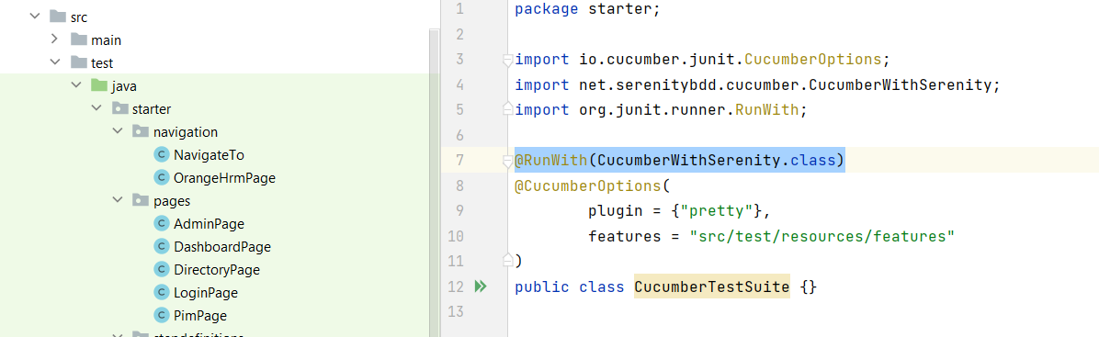

7.Feature file under **src/test/resources/features/search**

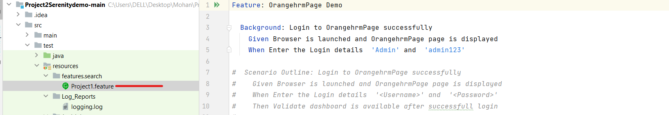

8.Creating **log4j.properties** in parent folder with required details and saving under **src\\test\\resources\\Log_Reports\\logging.log**

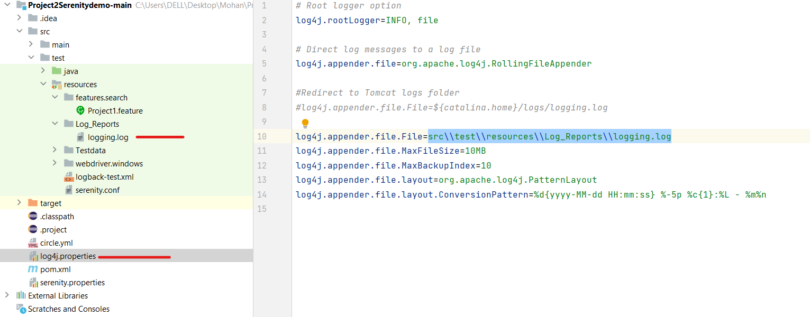

9.After required Setup for framework and coding part done, Navigate to command prompt and to respective folder run the Maven Command --🡪🡪 **mvn clean verify** based on the goals set in **POM.xml**

**\*\*\* without mvn command report will not be generated**

Report will be generated **---🡪🡪 target/site/serenity/index.html**

